Second Hands-on
Run and Test the Application
- Run SpringLearnApplication (main class)

Test endpoints:
http://localhost:8083/hello
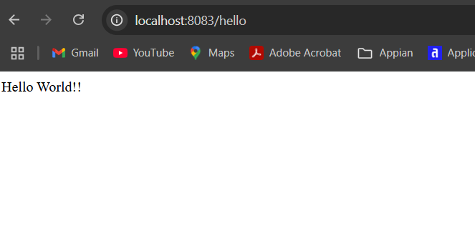
http://localhost:8083/country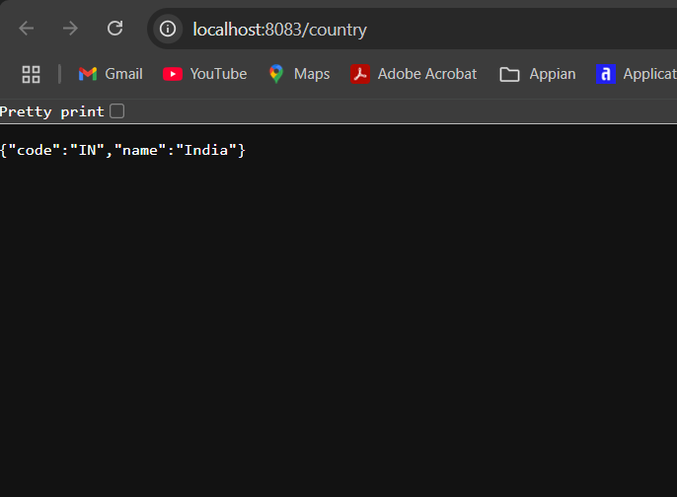
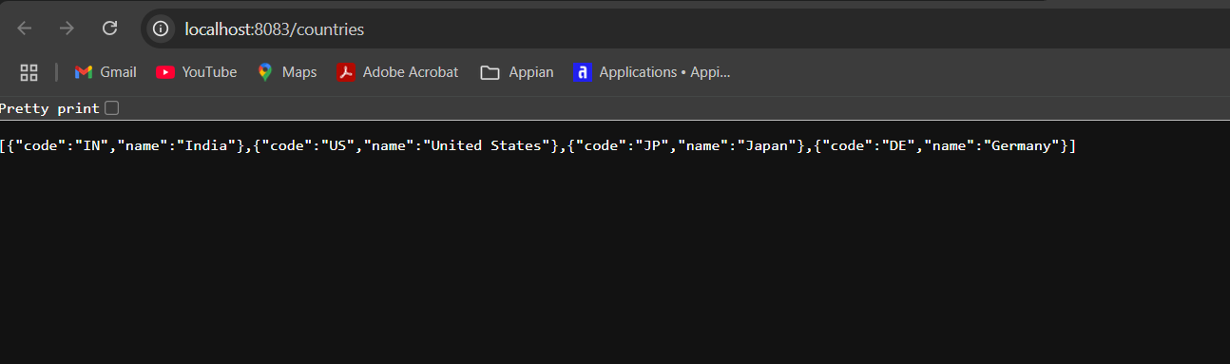
http://localhost:8083/countries

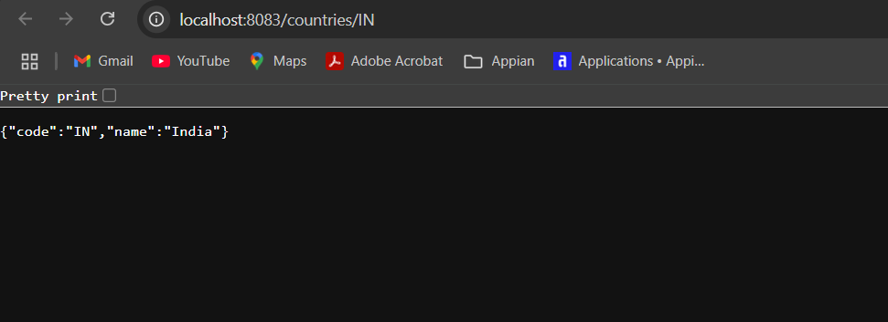
http://localhost:8083/countries/IN
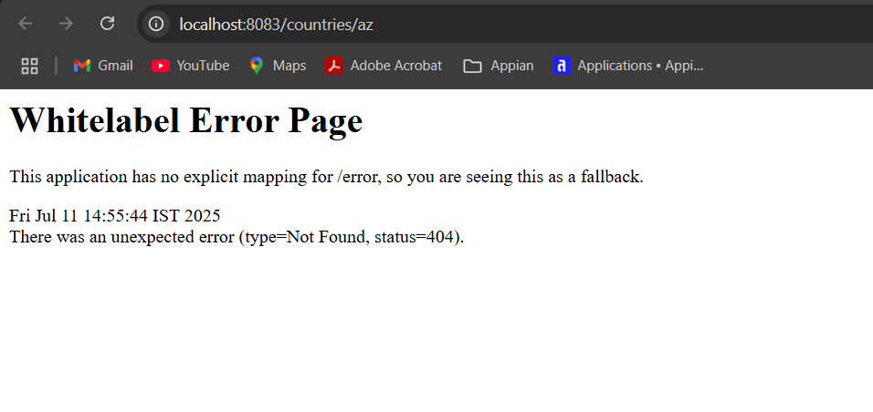
http://localhost:8083/countries/az (should return 404)

